22.39: a)(i) 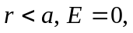 since 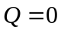
(ii) 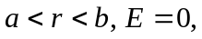 since 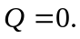
(iii) 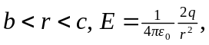 since 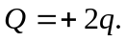
(iv) 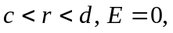 since
(v) 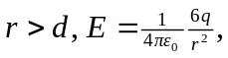 since 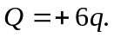

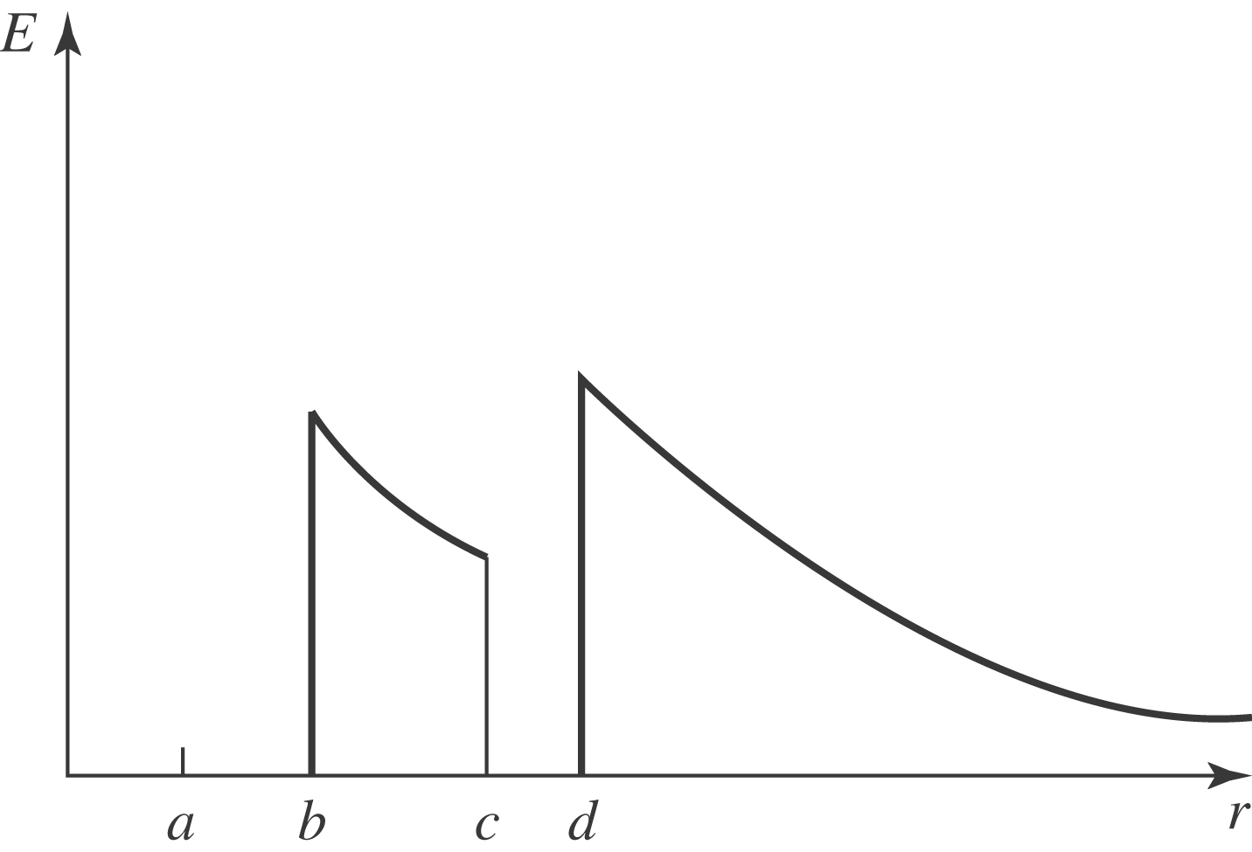

b)(i) small shell inner: 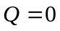
(ii) small shell outer: 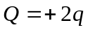
(iii) large shell inner: 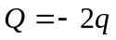
(iv) large shell outer: 